Installing MSAMExcel:

Unzip MSAM_AddIn.zip to a directory such as C:\MSAM_AddIn. If you want, you can delete this directory after it has been installed in Excel.

From inside that directory, Run the batch file “UpdateAddins.bat”.

You may need to run the Windows PowerShellscript unblock_files.ps1 from the directory containing the files (in this example C:\MSAM_AddIn) to unblock the add-in files.

Enable the Addin using File - > Options -> Add-ins -> Manage: Excel Add-ins then click the “Go …” button.
Select MSAMExcel Add-In.

From inside Excel, you should be able to see the new functions inside the Add-In.

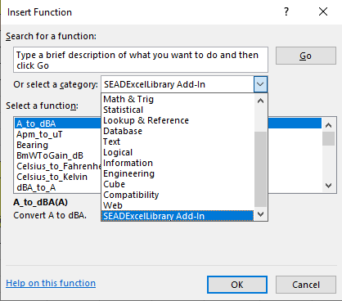

The spreadsheet “MSAMtoExcel_Sample.xlsx” provides a sample of the functions.

GLOBE terrain data:
Place the unzipped terrain files into a single directory (e.g. C:\USGS).

